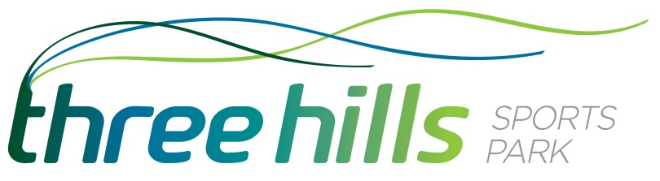

Experienced Bar Staff Required – Three Hills Sports Park
Situated on the outskirts of Folkestone, Three Hills Sports Park is a stylish and contemporary new building set in extensive grounds. Three Hills Sports Park is home to a variety of different sports clubs based in Folkestone. It also provides a venue for any occasion including team building events, business meetings and functions, evening wedding receptions, parties or outdoor events.
We are looking for experienced bar staff to join our friendly and professional team.
You will be responsible for:
- Maintaining high standards of hygiene throughout the bar and catering areas
- Food and beverage service
- Handling cash
- Setting up and taking down of equipment for functions and events
- Basic cleaning of the bar area
- Providing an excellent customer experience
Applicants must be well presented and highly motivated together with good communication and customer service skills. The successful candidate will:
- Have hospitality experience
- Demonstrate the experience, skills, maturity and aptitude to occasionally perform Duty Manager responsibilities when required
- Be positive and energetic, leading by example and setting team standards
- Have the ability to work with minimum supervision
- Possess qualities of discretion and honesty

Job Type: Casual hour contract
Salary: £8.21 per hour (NMW applies)

To apply: (quoting ref: BAR Vacancy) please email a CV and covering letter to nicholas.shaw@3hsp.co.uk

